Algebra 3-4 Name: __________________  
Chapter 2 Test Block: _______

Level 2

**Find the domain and range of the relation, then determine whether it is a function.**

1. {(2,1), (−4,5), (1,7), (2,−3), (−1,2)}

Domain: __________

Range: ___________

Function? _________

2. {(5,1), (−1,5), (1,2), (3,−3), (4,9)}

Domain: __________

Range: ___________

Function? _________

3. Given the graph below:

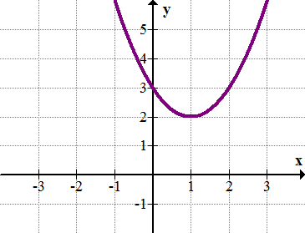

Domain: __________

Range: ___________

Function? _________

**Identify the Slope for the following lines.**

4. 4. Slope: __________

5. Slope: __________

6. (5,2) and (-3, 6) 6. Slope: __________

**Is the following a linear equation? If yes, write the equation as y = mx + b**

7. x | y 8. x | y 7. _______________

2 | 14 5 | 9  
 3 | 21 6 | 10  
 5 | 35 7 | 11 8. _______________

**Write the equation of the line given the following information.**

9. slope is 5 and through the point (2, ) 9. _______________

10. 10. _______________

Level 3

**Write the equation of the line through the two points.**

11. (-2, 1) and (8, -3) 11._______________

12. (-5, -7) and (0, 10) 12. _______________

**Graph and Describe the Transformations.**

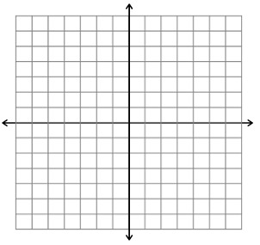13. $y=-3(x+4)^{2}+7$ Transformations:

14.



15. Transformations:

  
  
16. Transformations:

Level 4

17. Ann took a taxi home from the airport. The taxi fare was $2.10 per mile, and she gave the driver a tip of $5. Ann paid a total of $49.10.

Write an equation to determine the distance in miles x, between the airport and Ann's home.

18. Henry spends $90.00 on lunch and spends $16.00 on bananas. Hicks spend $120.00 on clothes. Henry borrowed money from Hicks to buy his items. In other words, Hicks paid for Henry. Hicks has a bank account with a balance of $250. How much will the purchase cost him? What would Hick’s bank balance be after all the debts were paid? Write an equation to explain how you reached the following. (Graph if needed).